**GREENLEAF SALES ANALYSIS REPORT**

**- BY SAKSHI SAHU**

**DATA ANALYST**

1. **EXECUTIVE SUMMARY**
   1. **Purpose of the analysis:** Gain a deeper understanding of GreenLeaf’s sales performance across products, channels, and teams. By studying historical transaction data, the analysis aims to uncover patterns, highlight growth opportunities, and address inefficiencies in the current sales process.
   2. **Objective of the analysis:** Translate raw sales data into actionable insights that support strategic decisions - such as identifying high and low-performing products, evaluating the effectiveness of sales channels, and measuring salesforce productivity. Ultimately, the analysis will guide GreenLeaf in optimizing its portfolio, strengthening channel strategies, and driving overall business growth.
2. **DATA SUMMARY**
   1. **Time Period:** Jan 2019 - March 2021
   2. **No of Records:**

* **798** records in Product Table
* **260K+** records in Sales Table
  1. **Key Features:**
     1. **Product Table**
* Product ID
* Product Name
* Product Group
* Product Category
  + 1. **Sales Table**
* **Order Date**
* Order Number
* Product ID
* Salesperson ID
* Salesperson
* Supervisor
* Manager
* Channel
* Quantity
* Unit Price

1. **METHODOLOGY OF ANALYSIS**
   1. **Extract**

* Extracted the raw data which is in multiple tables from ***Excel***to ***Power BI***.
* **Data understanding:**
* Schema
* Data exploration
  1. **Transform**
* Data cleaning
* Data understanding
  1. **Load**
* Loading clean data

1. **VISUALIZATIONS & INSIGHTS**
   1. **Product Group wise sales.**

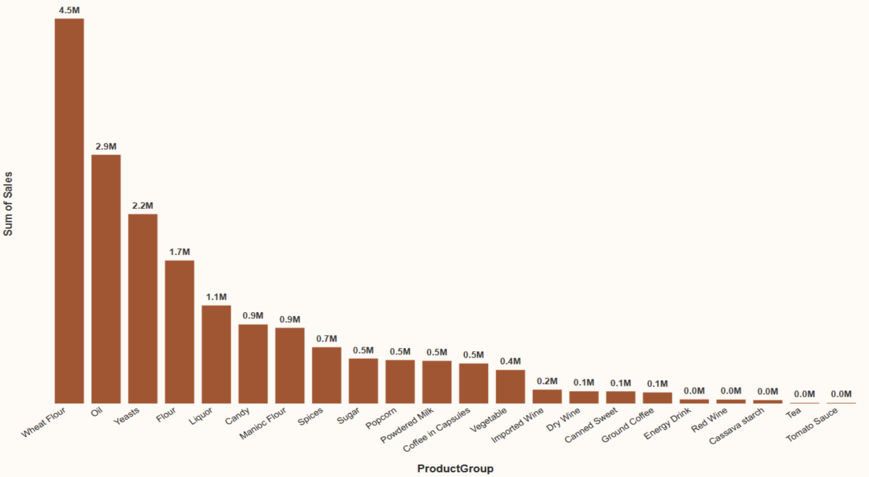

* **Observation:** Wheat Flour leads at sales, followed by Oil and Yeasts as the main revenue drivers. Mid-tier products like Flour, Liquor, Candy, Manioc Flour, and Spices contribute moderately, while categories such as Vegetables, Wines, Coffee, Tea, and Tomato Sauce record very low sales. Overall, sales are dominated by a few core products, with most other categories underperforming.
  1. **Top 5 Product Group**

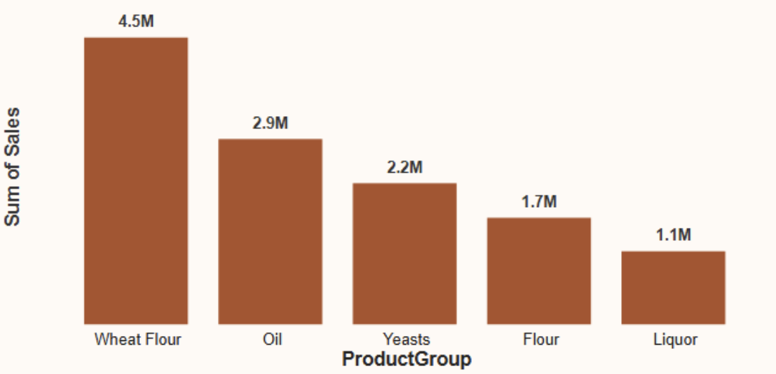

* **Observation**
  1. Bottom 5 Product Group

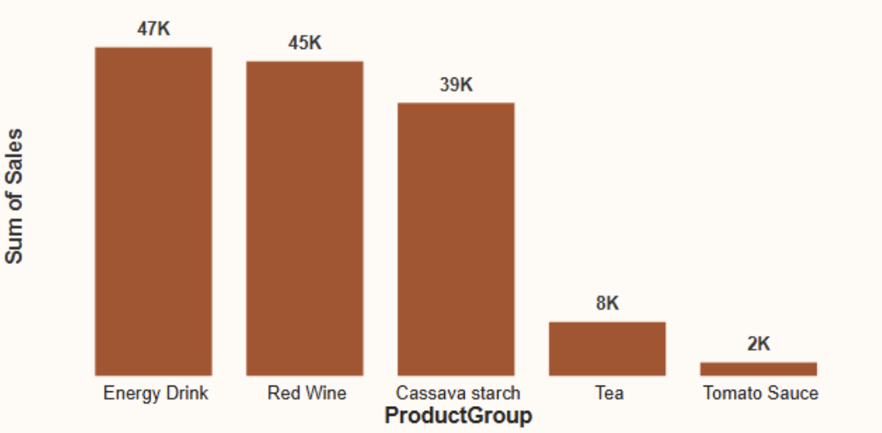

* **Observation**
  1. Question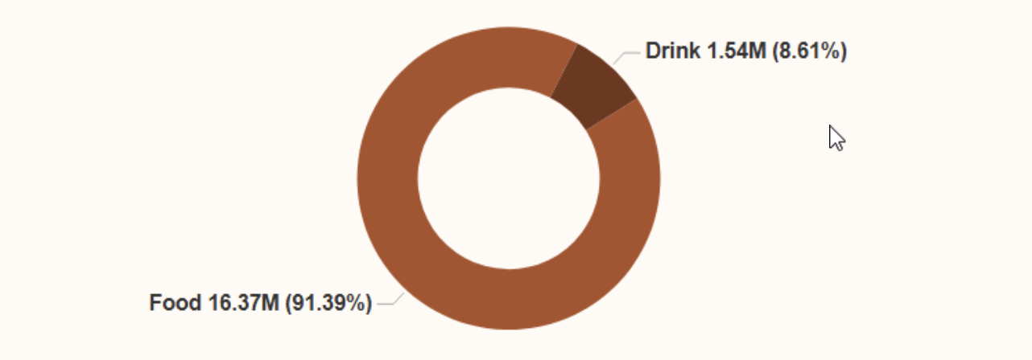
* **Observation**
  1. Question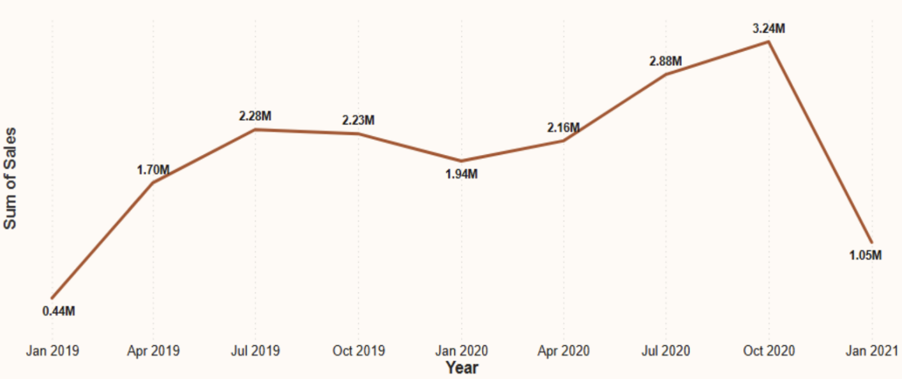
* **Observation**
  1. Question

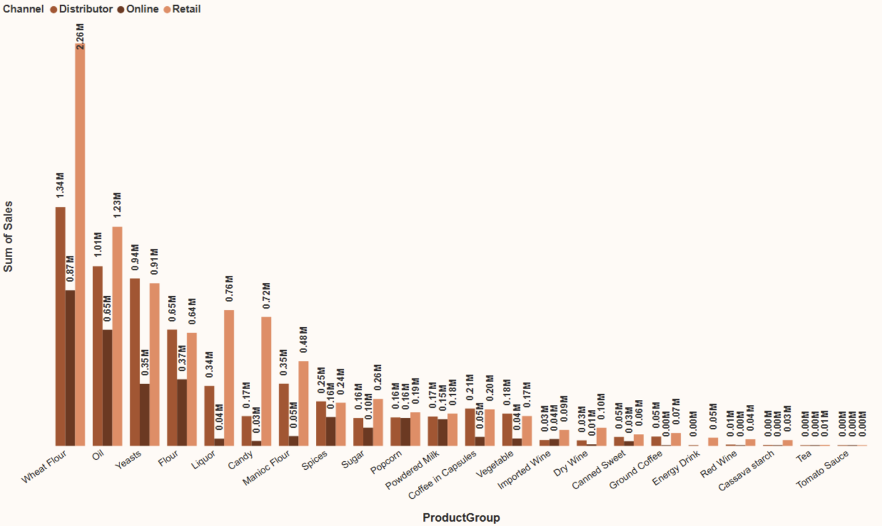

* **Observation**
  1. Question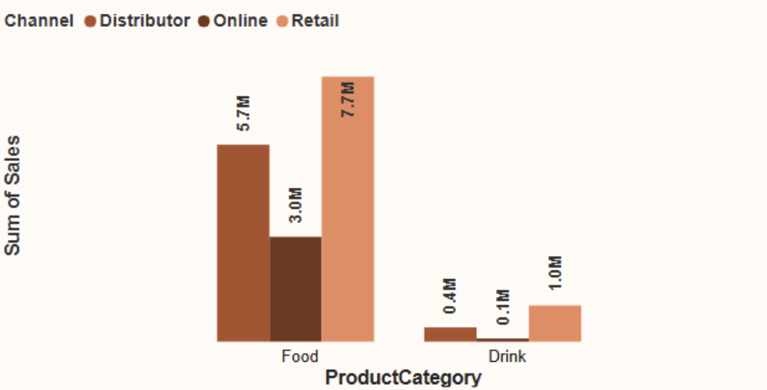
* **Observation**
  1. Question

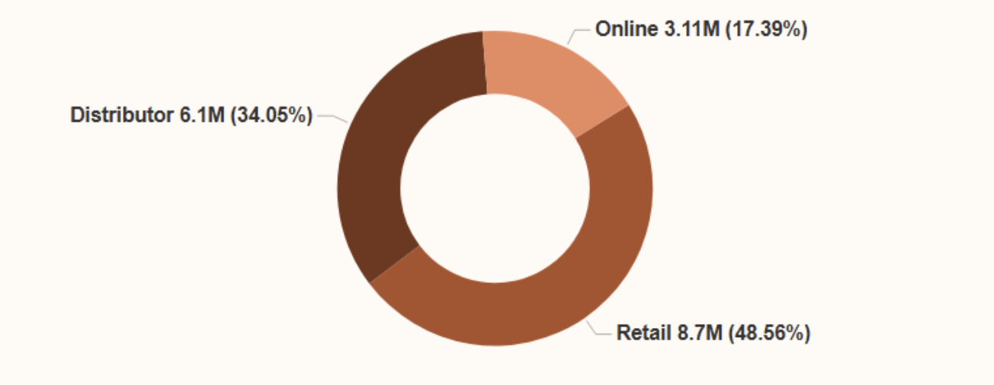

* **Observation**
  1. Question

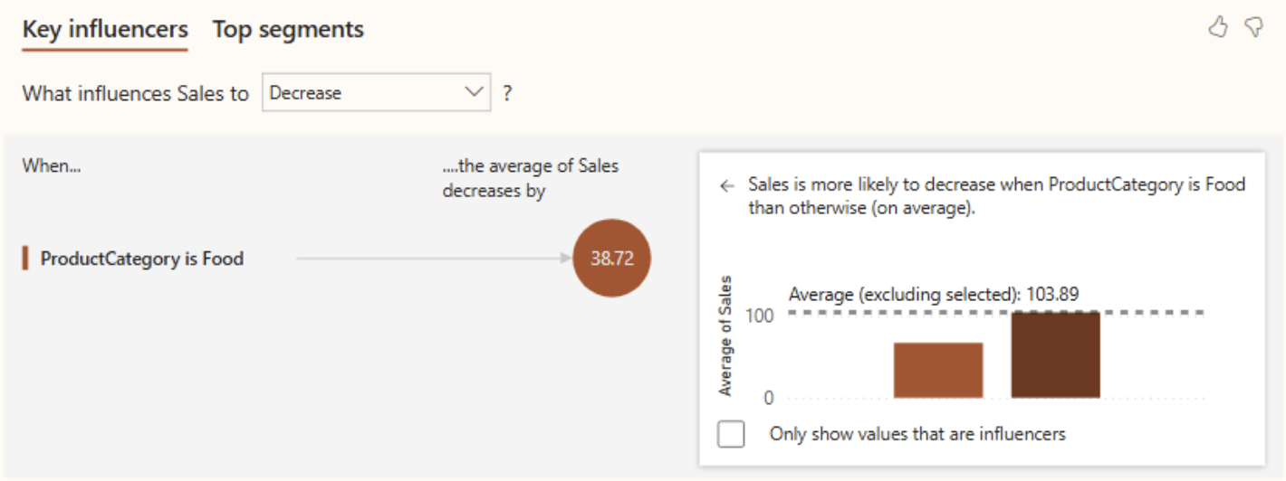

* **Observation**
  1. Question

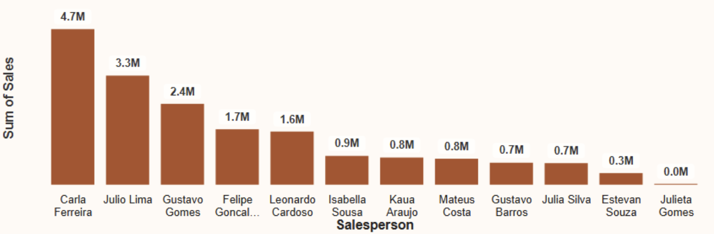

* **Observation**
  1. Question

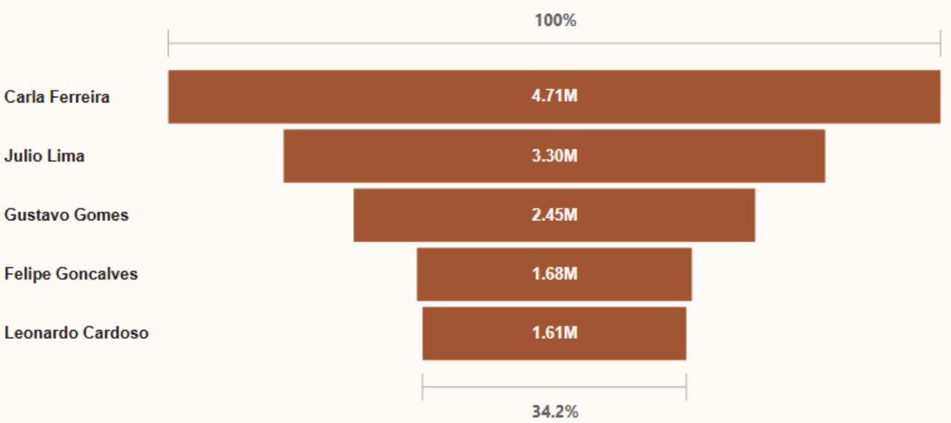

* **Observation**
  1. Question

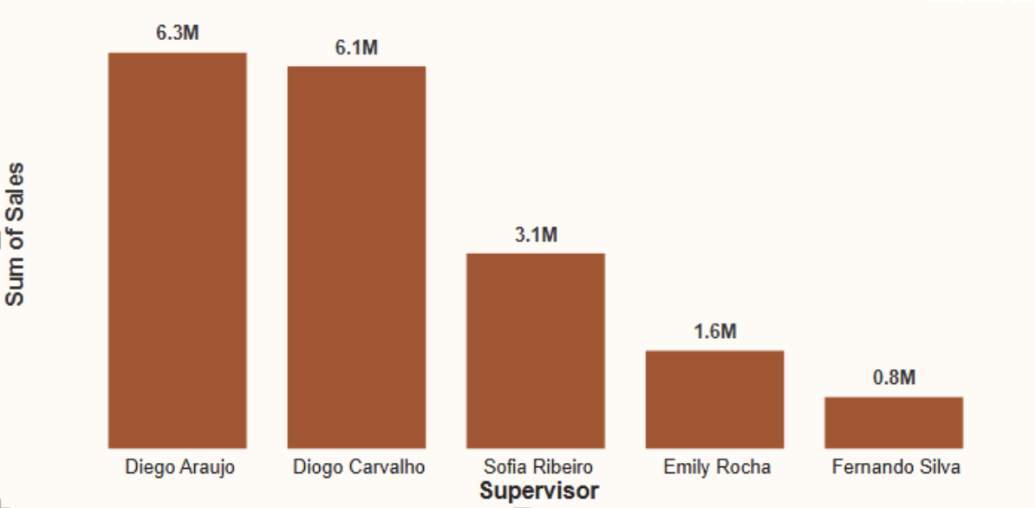

* **Observation**
  1. Question

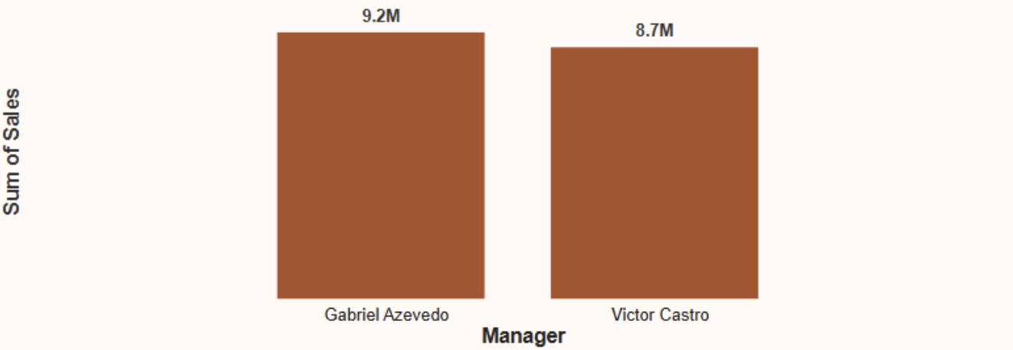

* **Observation**
  1. Question

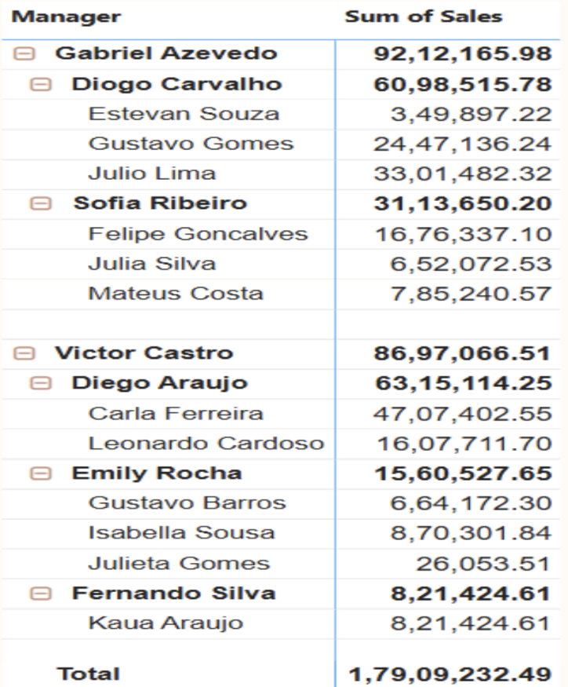

* **Observation**
  1. Question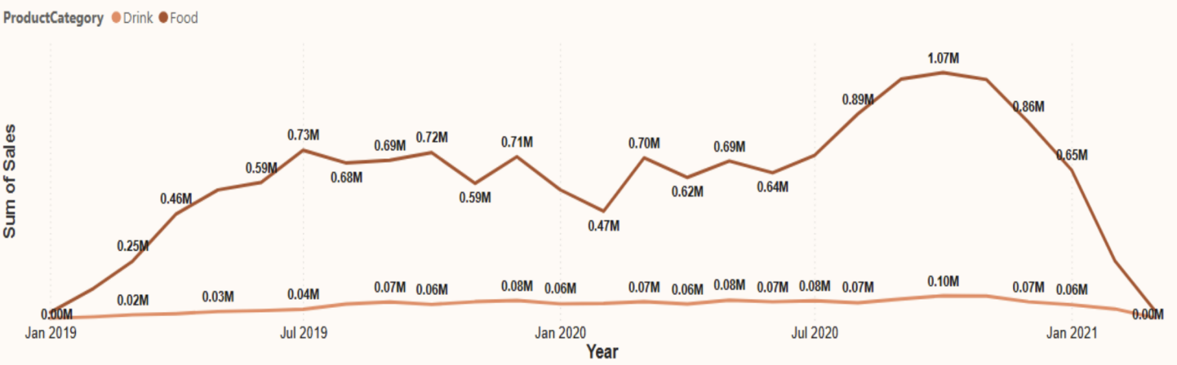
* **Observation**
  1. Question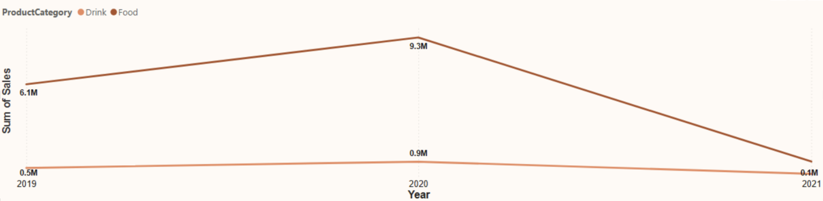
* **Observation**
  1. Que

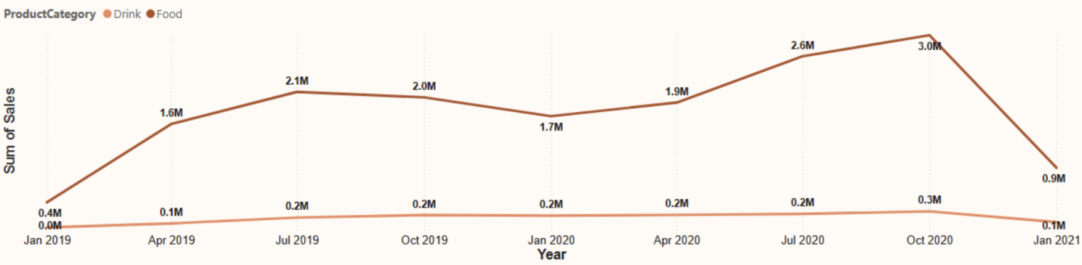

* **Observation**
  1. Question
* **Observation**
  1. Question
* **Observation**
  1. Question
* **Observation**

1. **KEY FINDINGS**
2. **CONCLUSION & RECOMMANDATION**